Module 5.2: Java GUI Swing and Scale
Contents
- Abstract Window Toolkit 1
- Java Swing 2
- Swing vs. AWT 2
- Basic Structure of a Swing Application 3
- Advantages of swing class 6
- Disadvantages of Swing 6
- Swing Component Hierarchy 7
- Event Handling in Swing 8
- ActionListeners and Other Listeners in Swing 9
- ActionEvent and Processing with ActionListener 11

Abstract Window Toolkit
AWT (Abstract Window Toolkit) is a Java package that provides the ability to create graphical user interfaces (GUIs) in Java applications. java.awt.*; package provides classes like Button, Frame, Canvas, Color, Choice etc. Key Features of AWT
- Heavyweight Components: AWT components are heavyweight because they rely on the native operating system's graphical user interface. This means that they are rendered by the OS rather than by Java itself.
- Platform Dependency: Since AWT components are tied to the native system, their appearance and behaviour can vary between different operating systems.
- Event Handling: AWT supports event-driven programming, allowing developers to handle user interactions (like clicks and key presses) through event listeners.
- Basic GUI Components: AWT provides fundamental GUI components such as buttons, labels, text fields, checkboxes, and menus.
Common AWT Components
- Frame: A top-level window with a title and borders.
- Button: A clickable button that performs an action when pressed.
- Label: A non-editable text display component.
- TextField: A single-line input field for text.
- TextArea: A multi-line input field for text.
- Checkbox: A box that can be checked or unchecked.
- List: A list of items from which users can select.
- Menu: A dropdown menu containing various options.
Advantages of AWT
- Simplicity: AWT has a simpler API compared to other GUI frameworks, making it easier for beginners to use.
- Native Look and Feel: AWT components provide a native look and feel on different operating systems, as they use the underlying system's UI.
- Lightweight Footprint: AWT applications tend to use fewer resources compared to more complex frameworks.
Disadvantages of AWT
- Heavyweight Components: AWT components can be slower and consume more memory due to their dependence on native resources.
- Limited Components: AWT provides a basic set of components compared to other GUI frameworks like Swing or JavaFX.
- Inconsistent Behaviour: Because AWT relies on the underlying OS, the appearance and behaviour of components may vary across platforms.
- Limited Customization: AWT components are less customizable compared to Swing components, which support a pluggable look-and-feel.

Java Swing
Swing is a part of the Java Foundation Classes (JFC) library and serves as an extension of the Abstract Window Toolkit (AWT) for creating windowed applications in Java. It allows us to use more tools on a simple and lightweight platform, extend the functionality, and improve the result by supporting drag and drop. Swing is built on the top of AWT API and entirely written in Java.
Java Swing provides a simple way to create graphical user interfaces, making it easy for beginners to use and very effective for experienced developers. This simple application introduces the basics of creating GUIs with Swing and can be a stepping stone to creating more interactive and intuitive applications.
javax.swing package provides classes such as JButton, JTextField, JTextArea, JRadioButton, JCheckbox, JMenu, JColorChooser, etc. for the Java swing API.
- Lightweight Components: Swing components are written entirely in Java and do not rely on the underlying platform's windowing system, making them platform-independent.
- Rich Set of GUI Components: Swing provides a comprehensive set of GUI components, including buttons, checkboxes, radio buttons, tables, trees, and more.
- Pluggable Look and Feel: Swing supports pluggable look-and-feel designs, allowing developers to customize the appearance of GUI widgets/applications(Look) and the way they behave(Feel) to match different platforms or custom themes.
- Event Handling: Swing follows a robust event-handling model, making it easy to manage user interactions.
- MVC Architecture: Swing components follow the Model-View-Controller (MVC) design pattern, separating the data (model) from the user interface (view) and the logic that controls the interaction (controller).
- Highly Customizable Components: Swing components can be customized and extended easily to create rich user interfaces.

Swing vs. AWT
Feature | Swing | AWT
Component Type | Components are platform independent | Components are platform dependent
Component Handling | Uses lightweight components that are drawn in Java, not dependent on the underlying OS | Uses heavyweight components tied to the native OS
Look-and-Feel | Supports pluggable look-and-feel; can be customized easily | Limited to the native look-and-feel of the OS
Event Handling | More advanced event handling capabilities | Basic event handling
Flexibility and components | Highly customizable; offers more components and layout managers | Less flexible; fewer components available
Performance | Generally slower due to rendering overhead | Faster due to direct access to native resources
Complexity | More complex due to a richer feature set | Simpler API with fewer features
MVC support | Swing follows MVC | AWT doesn’t follows MVC where model represents data, view represents presentation and controller acts as an interface between model and view
Accessibility | Better support for accessibility features | Limited support for accessibility

Basic Structure of a Swing Application
- Import Required Packages
- Create the Main Application Class
- Create and configure the JFrame
- Create and Add Components to the JFrame
- Implement Event Handling
- Set the JFrame Visibility
- Import Required Packages: In Java, delivery packages are required so that we can use the classes and interactions in these packages according to our needs in our program. Packages are used to group related and interactive resources together to help us plan and develop policies. For the Swing application here, we are importing the following packages:
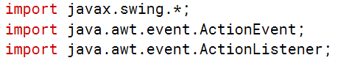
  - javax.swing: provides a set of 'lightweight' (all-Java language) components that, unlike the AWT components, are platform-independent and can be customised easily. Swing includes components such as buttons, text fields, labels, tables, trees, and more.
    - java.awt.event.ActionEvent:
    - The java.awt.event package provides interfaces and classes for dealing with different types of events fired by AWT and Swing components.
    - ActionEvent is a class that represents the occurrence of an action. It is generated when a component-defined action occurs, such as when a button is clicked.
  - import java.awt.event.ActionListener;
    - The java.awt.event.ActionListener interface is used to receive action events.
    - The interface defines a single method, actionPerformed(ActionEvent e), which is called when an action event is fired. In this case, it is used to handle the button click event.
- Create the Main Application Class: The main class of a Java Swing application is the implementation of the first application. This class usually has a main method that sets the application's window size and adds necessary properties to it. The main applications in the program are:
- Create and Configure the Jframe: JFrame is the main window of a Java Swing application. It acts as a container for all other objects such as panels, buttons, labels, and text. The Jframe used here is a window with decorations such as a title, border, and buttons for closing and minimizing.
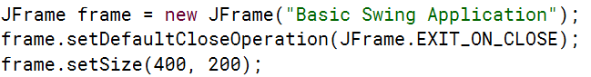
- Create and Add Components to the JFrame: Creating and adding components to a JFrame involves several steps, including initializing the frame, creating objects (such as buttons, labels, tags), and adding these objects to the frame details pane.
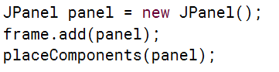
- Implement Event handling: Using event handlers in a Swing application involves adding listeners to objects (such as buttons) that can trigger events. You should also set the JFrame to visible at the end of the configuration to ensure that the window is displayed while the application is running.
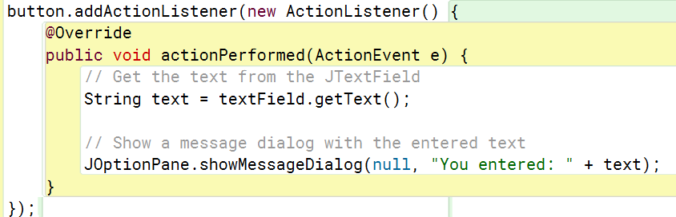
- Set the Jframe visibility: It is important to set the JFrame view to display the window while your application is running. This is usually done at the end of the JFrame configuration to ensure that all components are added and configured correctly before displaying the window.

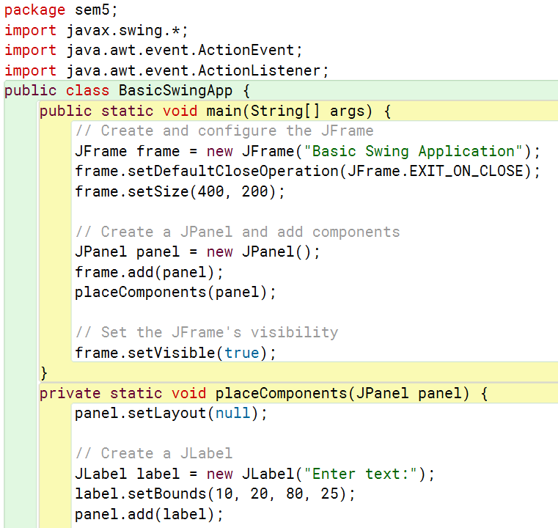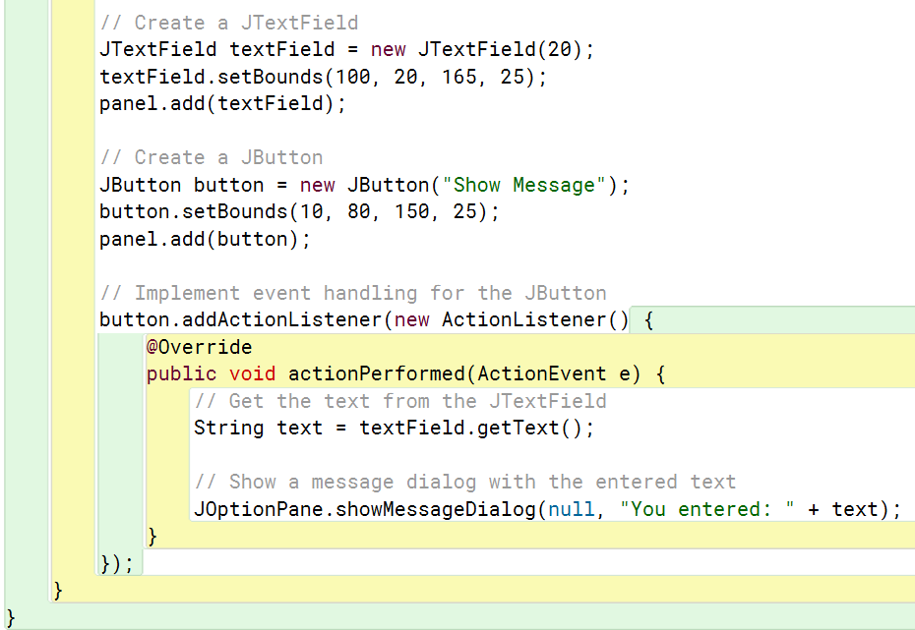

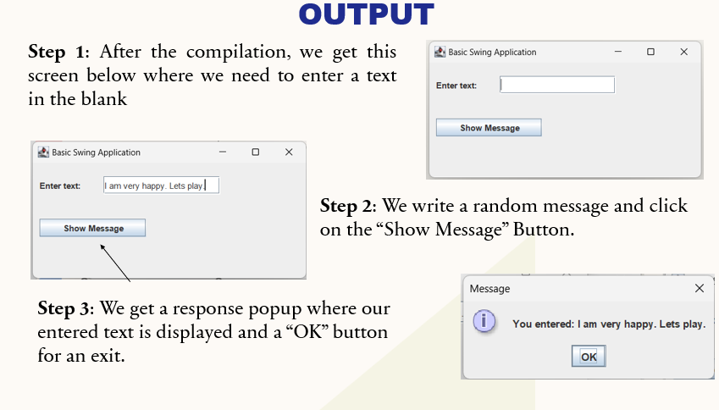

Advantages of swing class
- Platform Independence: Swing components are written entirely in Java, making them platform-independent. This ensures consistent behavior and appearance across different operating systems.
- Rich Set of Components: Swing offers a comprehensive set of GUI components, such as buttons, checkboxes, radio buttons, tables, trees, text fields, and more. These components are highly customizable.
- Pluggable Look-and-Feel: Swing supports the pluggable look-and-feel (PLAF) architecture, allowing developers to change the appearance of applications dynamically. Applications can look like native applications on different platforms or have a custom look.
- Customizability: Swing components can be easily customized. Developers can subclass existing components or create new ones to meet specific requirements.
- Lightweight Components: Unlike AWT (Abstract Window Toolkit), Swing components are lightweight, meaning they are not dependent on native peers. This results in more efficient use of resources and better performance.
- Advanced Features: Swing provides advanced features such as drag-and-drop support, double buffering, and a powerful text component framework that supports formatted text, hyperlinks, and more.
- Extensibility: Swing is highly extensible. Developers can extend existing components or create new components with custom behavior.

Disadvantages of Swing
- Performance: Swing applications can be slower compared to native applications due to additional overhead.
- Look and Feel: Swing may not provide a consistent native look and feel across different platforms, leading to a less integrated user experience.
- Complexity: Building complex UIs can become cumbersome with Swing, requiring more code and design effort.
- Heavyweight: Swing components can consume more memory than lightweight components, affecting resource usage.
- Limited Accessibility: Swing does not have built-in support for some accessibility features, making it harder for users with disabilities to interact with applications.

Swing Component Hierarchy
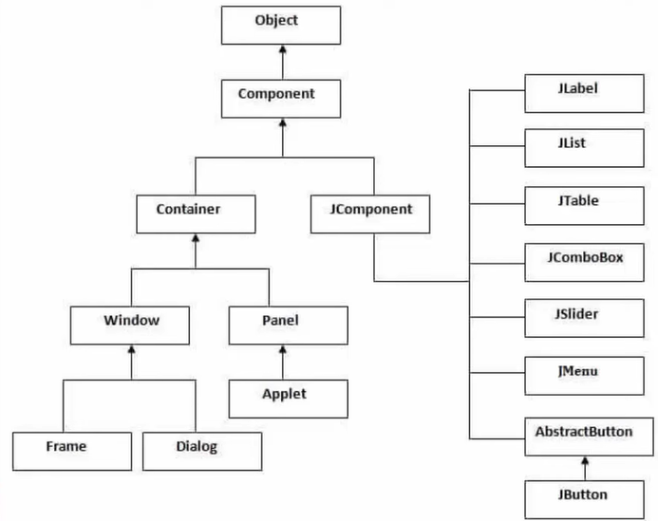
- Top-Level Containers: These are the primary containers that hold other components. Every Swing application must have at least one top-level container.
  - JFrame: Represents a window with standard decorations (title bar, borders, etc.). It is commonly used for main application windows.
  - JDialog: A pop-up window used for secondary tasks. Can be modal (blocking input to other windows) or non-modal.
  - JApplet: A Swing version of an applet, which is embedded in web browsers. (Less commonly used now due to the decline of applets.)
  - JLayeredPane: Allows stacking of components in layers, providing greater control over the display order.
  - JRootPane: The base class for Swing top-level containers, providing a common structure for JFrame and JDialog.

- Root Component: JComponent is the base class for all Swing components except for the top-level containers. It provides common methods for painting, event handling, and borders. All Swing components, like buttons, labels, and panels, inherit from JComponent.

- Containers: These components are used to organize and group other components.
  - JPanel: A generic container for grouping components, often used to create layouts.
  - JScrollPane: Provides a scrollable view for other components like JTextArea or JList.
  - JTabbedPane: Allows switching between different panels (tabs) within the same window.
  - JSplitPane: Divides two components, allowing the user to resize them.
  - JToolBar: A container for grouping tool buttons and controls.

- Basic Swing Components: These are the most used components for building user interfaces.
  - JButton: A clickable button.
  - JLabel: Displays non-editable text or images.
  - JTextField: A single-line text field for user input.
  - JTextArea: A multi-line text area for input.
  - JList: Displays a list of items for selection.
  - JComboBox: A drop-down list that allows selection from a list of options.
  - JCheckBox: A box that can be checked or unchecked.
  - JRadioButton: A button in a group where only one can be selected at a time.

- Specialized Components:
  - JSpinner: Allows users to select a value from a fixed set or within a range.
  - JProgressBar: Displays progress for ongoing tasks.
  - JSlider: A control for selecting a value within a range by sliding a knob.

- Layout Managers: Swing components rely on layout managers to organize the components within containers. Common layout managers include:
    - BorderLayout: Divides the container into five areas: North, South, East, West, and Center.
    - FlowLayout: Places components in a row, wrapping to the next line as needed.
    - GridLayout: Arranges components in a grid of specified rows and columns.
    - BoxLayout: Aligns components either vertically or horizontally.

- Event Handling: Components generate events that can be handled by implementing listeners. Common listener interfaces include:
    - ActionListener: For handling button clicks and other actions.
    - MouseListener: For mouse events (clicks, enters, exits).
    - KeyListener: For keyboard events.

- Lists, Tables, and Trees:
    - JList: Displays a list of items.
    - JTable: Displays data in tabular form.
    - JTree: Displays hierarchical data.

Event Handling in Swing
Event handling in Swing is a crucial aspect that allows applications to respond to user interactions, such as mouse clicks, keyboard inputs, and other actions. Swing operates on an event-driven programming model, where the flow of the program is determined by events generated by the user or the system.
- Event-Driven Programming: is a programming paradigm where the flow of the program is determined by events—actions or occurrences that are detected by the program. These events can be triggered by user actions or other sources.
- How It Works: In Swing, when a user interacts with a GUI component (like clicking a button or typing in a text field), an event is generated. This event is then dispatched to the appropriate event handler.
- Components of Event Handling:
  - Event Source: This is the component that generates an event. For example, a button is an event source when it is clicked.
  - Event Object: When an event occurs, an event object is created that contains information about the event. For instance, a MouseEvent contains details about the mouse click, such as its position and the button clicked.
  - Event Listener: This is an interface that defines methods to handle specific types of events. For example, the ActionListener interface is used to handle action events (like button clicks).
- Event Registration: To handle events, you need to register an event listener with the event source. This is done using the add method provided by the component. For instance, to add an ActionListener to a button, you would use:
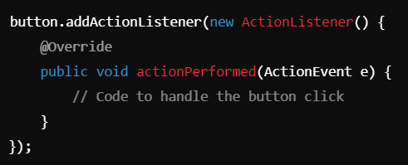
- Event Dispatching: When an event occurs, the event dispatching thread (EDT) sends the event to the registered listener. The listener then executes the appropriate method to handle the event. In Swing, all event handling occurs on the EDT to ensure thread safety and proper rendering of the GUI.
- Types of Events: Swing supports various types of events, including:
    - Action Events: Triggered by actions such as button clicks or menu selections. Handled by the ActionListener interface.
    - Mouse Events: Triggered by mouse actions (click, press, release, enter, exit). Handled by the MouseListener and MouseMotionListener interfaces.
    - Key Events: Triggered by keyboard actions (key press, key release). Handled by the KeyListener interface.
    - Window Events: Triggered by actions related to window management (opening, closing, iconifying). Handled by the WindowListener interface.

ActionListeners and Other Listeners in Swing
In Swing, listeners are interfaces that define methods to handle specific types of events. Implementing these interfaces allows your application to respond to user actions, such as clicking a button, moving the mouse, typing on the keyboard, or interacting with windows.
- ActionListener: Handles action events, such as button clicks. Methods:
    - void actionPerformed(ActionEvent e): Invoked when an action occurs.

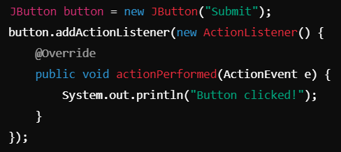

- MouseListener: Handles mouse events (clicks, presses, releases, enters, exits). Methods:
    - void mouseClicked(MouseEvent e)
    - void mousePressed(MouseEvent e)
    - void mouseReleased(MouseEvent e)
    - void mouseEntered(MouseEvent e)
    - void mouseExited(MouseEvent e)
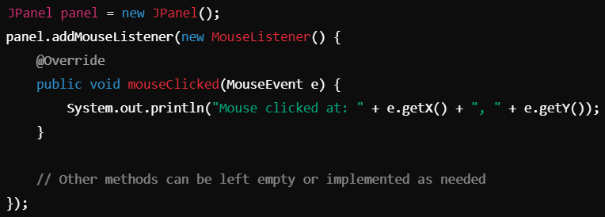

- KeyListener: Handles keyboard events (key presses and releases). Methods:
    - void keyTyped(KeyEvent e)
    - void keyPressed(KeyEvent e)
    - void keyReleased(KeyEvent e)
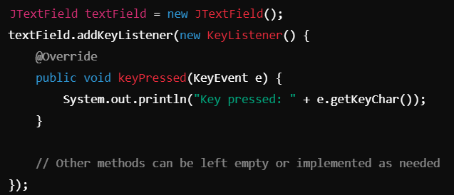
- WindowListener: Handles window events (opening, closing, iconifying, etc.). Methods:
    - void windowOpened(WindowEvent e)
    - void windowClosing(WindowEvent e)
    - void windowClosed(WindowEvent e)
    - void windowIconified(WindowEvent e)
    - void windowDeiconified(WindowEvent e)
    - void windowActivated(WindowEvent e)
    - void windowDeactivated(WindowEvent e)
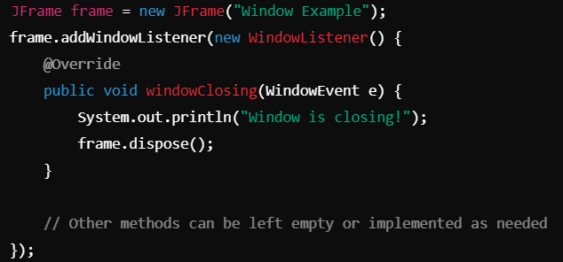

ActionEvent and Processing with ActionListener
- ActionEvent is a class in the java.awt.event package that represents an action event, such as a button click. It contains information about the event, including the source component (the button that was clicked).
- Creating ActionEvent: An ActionEvent is automatically created when an action occurs, such as clicking a button.
- Processing ActionEvents:
  - To process ActionEvent, you implement the ActionListener interface and define the actionPerformed method.
  - The ActionEvent object passed to actionPerformed contains information about the event, such as the command string, source, and modifiers.
Output
